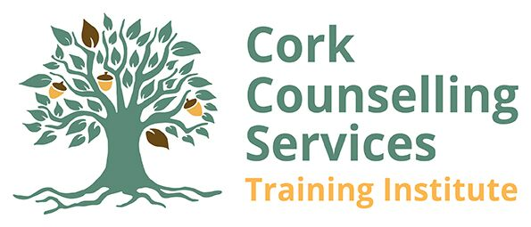

B.SC. (HONS) COUNSELLING & PSYCHOTHERAPY (Top-up Programme)

SUPPLEMENTARY APPLICATION FORM 2023

PERSONAL DETAILS

Name _____________________________
Mobile ____________________________

E-mail ____________________________

POST-QUALIFICATION

Further personal development work undertaken ___________________________________

________________________________________________________________________________

________________________________________________________________________________

Further professional development work undertaken ________________________________

________________________________________________________________________________

________________________________________________________________________________

WELL-BEING

How do you usually care for yourself? _____________________________________________

_________________________________________________________________________________
What current circumstances in your life will require support in order for you to complete the degree?
_________________________________________________________________________________

What supports have you put in place that are particular to your current personal circumstances? ____________________________________________________________________________________________________________________________________________________________________

_______________________________

PERSONAL STATEMENT

Applicants are required to enclose a 2000-word personal statement on the role of relationship in the personal and professional development and how this relates to their application. This statement should make reference to the following points:
(Max 1,500 words)
Role of relationships in your:
  - Personal development
  - Clinical practice
  - Theoretical knowledge
(Max 500 words)
  - Strengths and weaknesses
  - How do you anticipate that studying at Degree level will address your needs for future development?

Signature of applicant: ________________________________

Date:__________________________

